Table of Contents:
Page 2: Project idea

Page 3: Algorithms

Page 4: UML Activity diagram

Page 5: Class UML

Page 6: EXCEPTION HANDLING paragraph.

Page 7 and 8: SEARCH, SORT, STORAGE.
Page 9: Picture of Program Running

Project Idea:
For my project, I have thought of the idea of creating a program that will primarily help students, but could be used by anyone trying to learn something new. What I’m thinking so far is that the program will start with a 'main menu' that will ask if you want to review old cards or create new ones. Then, when a user chooses to create a new card, the question and answer will be stored in classes and then pointers will be used to retrieve them for quizzing. This will display the cards, along with their respective answers and correct response times. I don’t fully understand overloading assignment, but I feel like I could use it to keep track of cards missed and cards fully understood by the user somehow. Then, the last thing I would try to incorporate is creating abstract data types, which would represent the flashcards themselves. The reason why a user would want to use the flashcard study program is because they can add the information they are trying to study. This will randomize the cards, remove the ones the user fully understands, and continue quizzing on the ones they don’t fully grasp. The data that the user will be entering into the flashcard quizzing program would be the questions and answers they want to be quizzed on.

Algorithms:
Open a file named flashcards.txt to see if user already has cards
if no card have user make a card
create flash card object
set right_counter to 0
tell the user to make a question for a card
set flash card question
have the user give the answer to the card
set flash card answer.
Add flash card to an array of flash cards
Ask if they want to leave or study.
While the user does not want to exit do the following
ask user if they want to make a new card or view cards or exit
if they want to make a card
create flash card object
set right_counter to 0
tell the user to make a question for a card
set flash card question
have the user give the answer to the card
set flash card answer.
Add flash card to an array of flash cards
Else if viewing already made cards and studying
Check the array size of flash cards
Get a random int between 0 and (flash card size -1)
Use the random number as array index
Show the cards question
Tell the user to take a sec to think and enter letter when they want to see the answer
Ask user if they got it right or wrong
If they say they got it right add a counter to the card
If counter is above 5 delete card.

else if user wants to leave
tell the user how many cards are in the array and say good bye
else
that wasn’t a correct command try again .

Activity diagram: 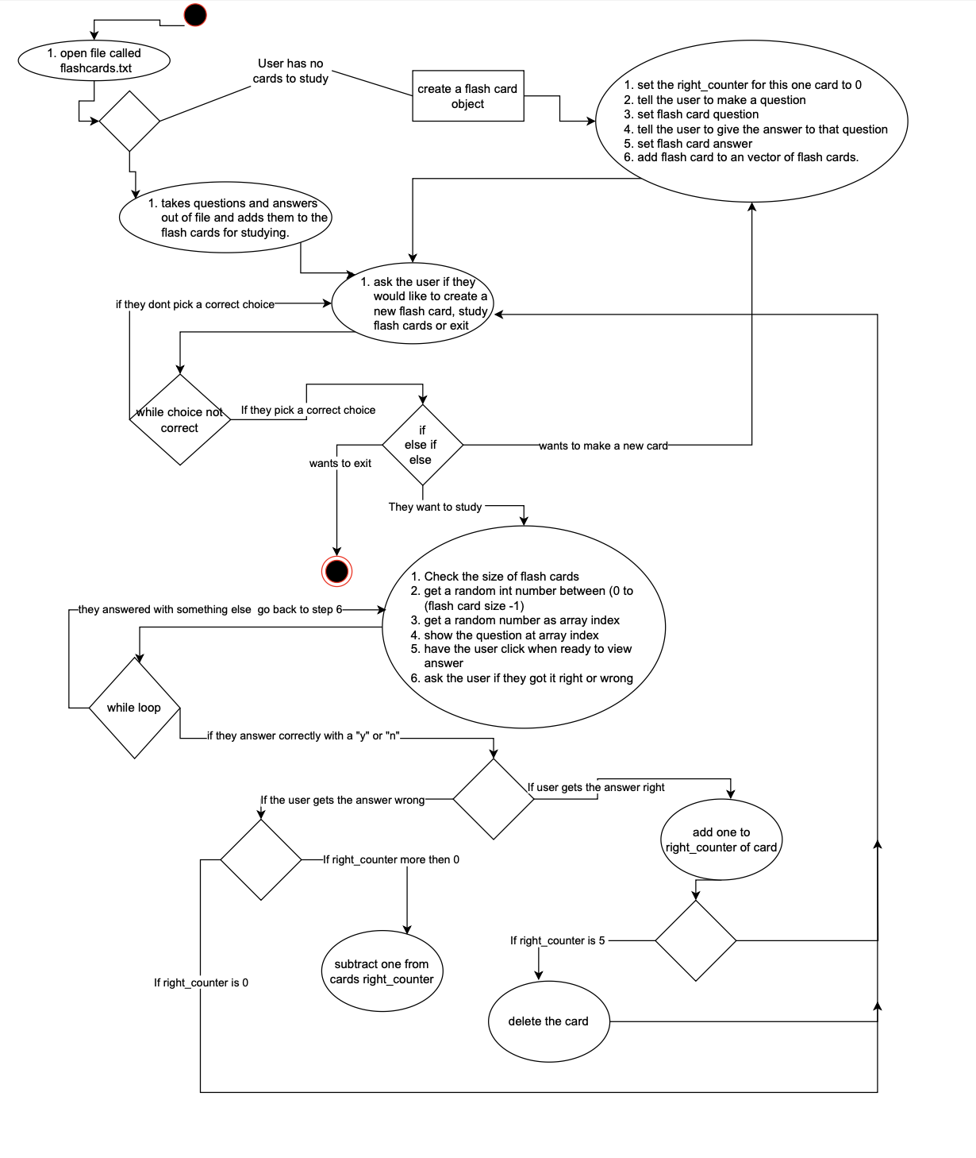

UML:
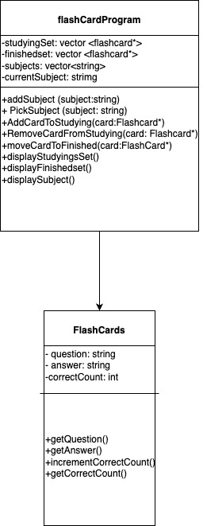

EXCEPTION HANDLING:

My program is designed to help people study in the same way that a physical flashcard would. In saying that, when you’re using a physical flashcard and, say, you're now adding another flashcard to your stack of 1000 other cards, learning isn’t about memorizing the answers word for word, but more about understanding the ideas. For exception handling in this case, for example, if the question is 'why is the sky blue,' one user could say, 'well, the sun's light reflects off the particles in the sky,' and if a different user answers the same question just by saying 'Rayleigh scattering,' both of them are right but answered it differently. So, for exception handling in this case, I will handle it just like in real-life flashcards: the user asks/tells themselves 'did I get that one right,' versus trying to make every answer have to be word for word, letter for letter correct.
Other exception handling things in my program will be such as when they go to choose what they want to do, the computer will check are there already cards, and are they typing in the correct options that they’re told to type to get to the options. Like when the computer asks the user, 'hey, did you get the question right (type “y” for yes and “n” for no),' the user isn’t allowed to type in 42; it should go back and say that is not a correct choice, please try again. Another thing I think the program should do for exception handling is if the user does mess up and they keep messing up over and over, they're obviously not there to study, so the program will let you try 'x' number amount of times, and then it saves the cards you have and ends the program.

SEARCH, SORT, STORAGE:

- Think about the following points:
  - Does your program store input data? What is it?
In my program the things are stored that are from user input data are questions/answers that the user needs to keep working on. When the program is running all the questions and answers are stored in a vector when the program isn’t running all the question/answers go in to a file. All questions will be odd line number all answers will be even numbers the questions answer is always one line below. Then in the program there is a counter for each card that counts up to 5 for the times that the card is answer correctly. When its answered correctly 5 times in a row the card is just deleted. If you get the card correct 4 times in a row and wrong the 5th it will go back to 0 times correct to make you study that card more so you fully know it.
  - Sorting algorithm?
Other than my questions going on the odd number lines then the answer right under the question on the even line in the file while the program isn’t being played there isn’t much sorting and things need to be randomized.
  - Searching algorithm?
There is no searching in my program. I want all the cards to pull up randomly not in order because the order of the questions isnt what needs to be studied. Then how many times someone gets cards right or wrong starts at 0 for every card when you start up/restart up the program.

  - If your program does something alternately, please write this up and submit it.
My program doesn’t really need the use of sorting in fact. I kind of want it to be more random. When someone makes real flashcards by hand, they don’t label each card with a number for an order they shuffle them to get the order even more random. The random order is because when studying I don’t think the user should be memorizing the order of the cards because then that just becomes question one answer Is 2 but the user at this point doesn’t even know what the question was just knows question one’s answer is 2. Whereas the way I have it with the randomness the user may memorize the question word for word and the answer that goes with it rather than the concepts of the question but at least that is better then memorizing an answer that goes with a card count.

Picture of Program Running: